# Project Smart Link Deployment Guide

## Overview

The purpose of this document is to provide guidance on setup and deployment to an ISV partner who is familiar with Office 365, Microsoft Azure and web application implementation.

**Prerequisites**

To setup the solution, make sure that you have:

* Office 365 Tenant (Business or Enterprise SKU)
* Microsoft Azure subscription
* Visual Studio 2017 (Enterprise, recommended)

## Azure App Registration

First step is to create the Project Smart Link Add-in web application. Make sure that you have Owner access on the Azure subscription before proceeding.

Sign into [Microsoft Azure portal](https://portal.azure.com/).

1. Go to Azure Active Directory and select the App registrations (Preview) blade:  
   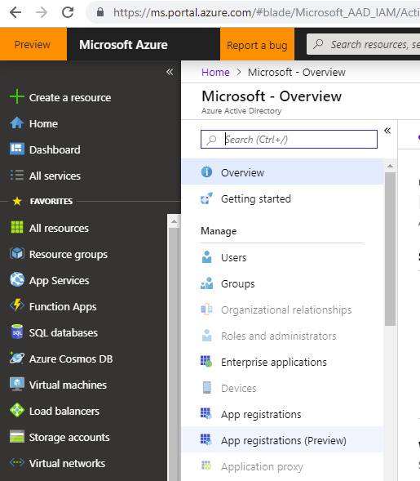
2. Click on the **New registration** button:  
   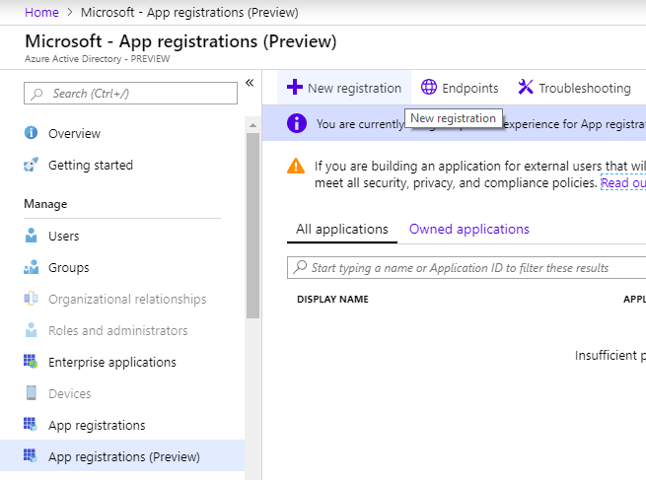
3. Add the name of the application being registered.
4. Select the supported account type: “**Accounts in any organizational directory and Microsoft accounts (e.g. Skype, Xbox, Outlook.com)**”
5. Add the Redirect URI (e.g. <https://myapp.azurewebsites.net>) and click on the “**Register**” button

**Create the Client secret:**

1. Click on the Certificates & secrets menu item
2. Click on the **New client secret** button
3. Add a **description** and choose the **Never** expires option as shown below:  
   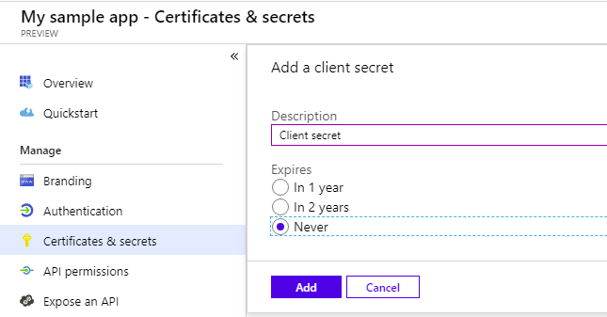
4. Click on the **Add** button
5. Copy and store the secret value as it is required later:  
   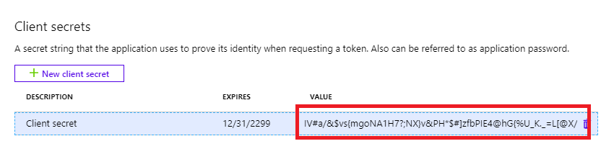

**Add the Redirect URI list**

1. Click on the **Authentication** menu item
2. The Project Smart Link requires 3 redirect URLs:

* https://{projectSmartLinkWebSite}/auth/end
* https://{projectSmartLinkWebSite}/auth
* https://{projectSmartLinkWebSite}

1. Click on the **Save** button.

**Expose the Project Smart Link API**

1. Click on the **Expose an API** menu item
2. Click on the **Add scope** button
3. Enter the Scope name: **access_as_user**
4. Choose **Admins and users**
5. Enter a consent name: **Access Project Smart Link Add-in**
6. Enter an admin consent description: **Allow the client application to access Project Smart Link Add-in API on behalf of the signed-in user.**
7. Enter a user consent display name: **Access Project Smart Link Add-in**
8. Enter a user consent description: **Allow the client application to access Project Smart Link Add-in on your behalf.**
9. Click the **Add scope** button

**Add the API permissions**

1. Click on the **API permissions** menu item
2. Click on the **Add a permission** button
3. Choose **Microsoft Graph**  
   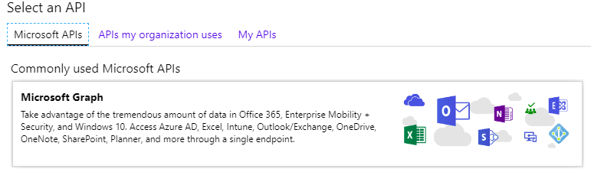
4. Select Application permissions:  
   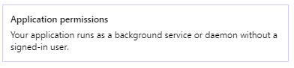
5. Add the following permissions:  
   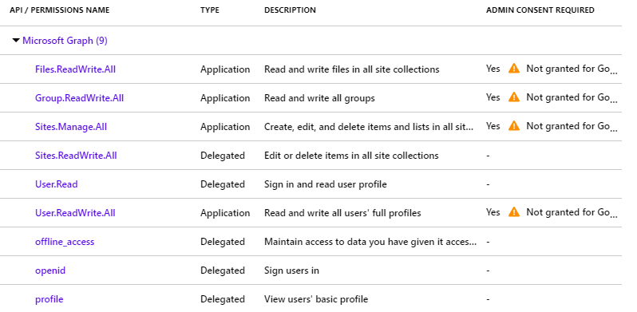
6. Finally add the Proposal Smart Link add-in API permission, click on the **Add a permission** button
7. Select **My APIs** tab:  
   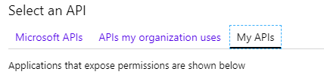
8. Select the application you registered from the list below
9. Check the **access_as_user** permission
10. Click on the **Add permissions** button

### Grant admin consent

1. Click on the **View API Permissions** button

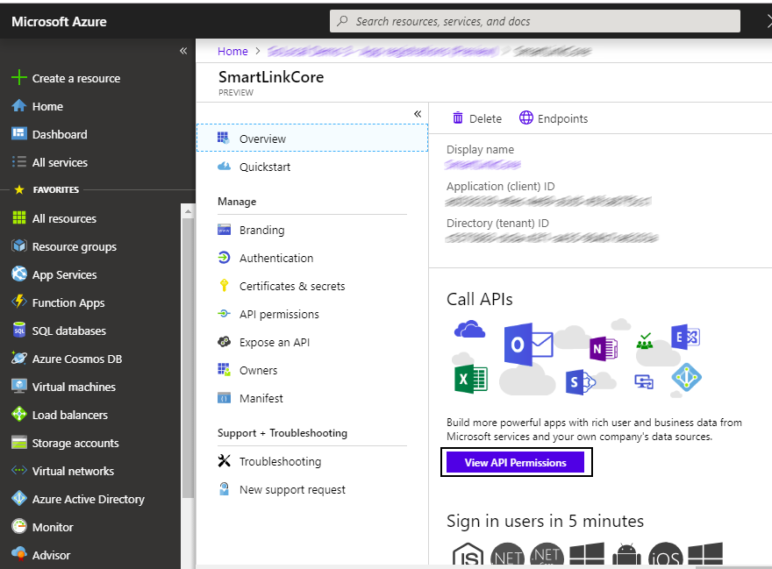

1. Click on the **Grant admin consent** for button

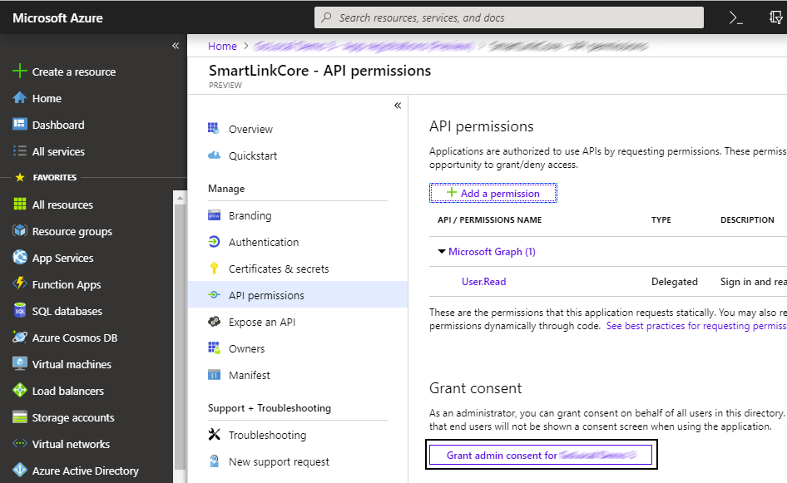

1. Finally click on the **Yes** button

## Deploy the app to Azure

Right-click on the **ProjectSmartLink.Web** project in Solution Explorer and select **Publish...**.

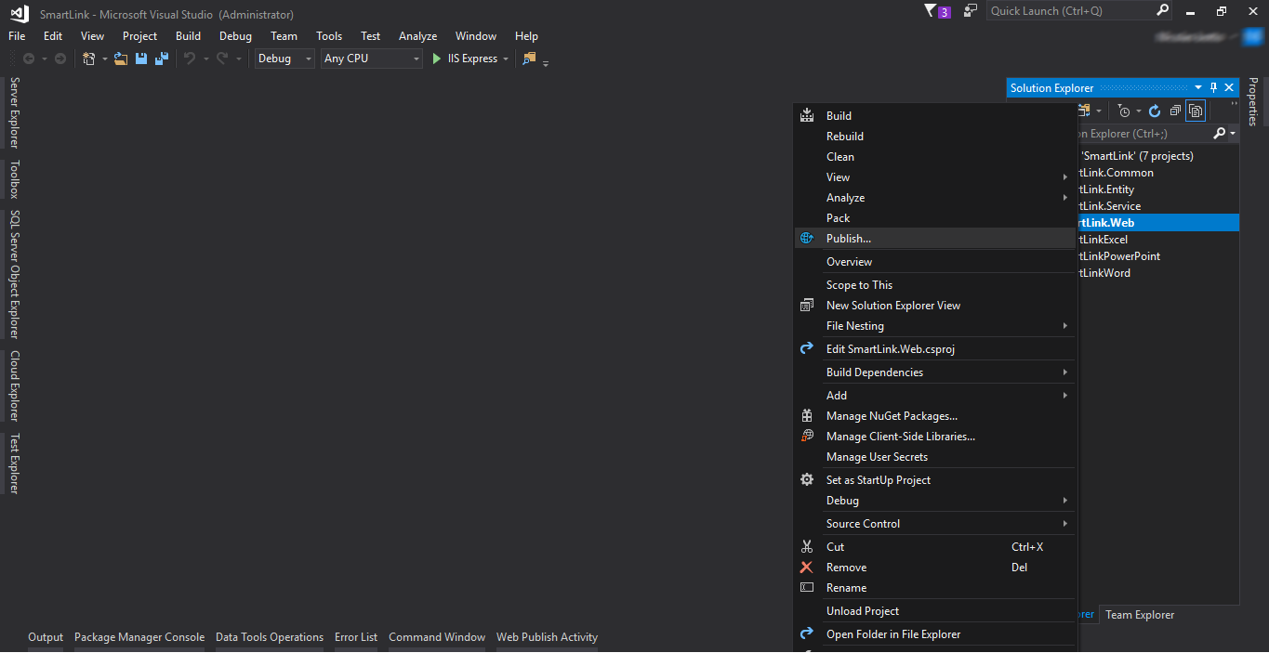

In the **Publish** dialog:

* Select **App Service**.
* Choose option **Create New**.
* Click on **Create Profile** button.

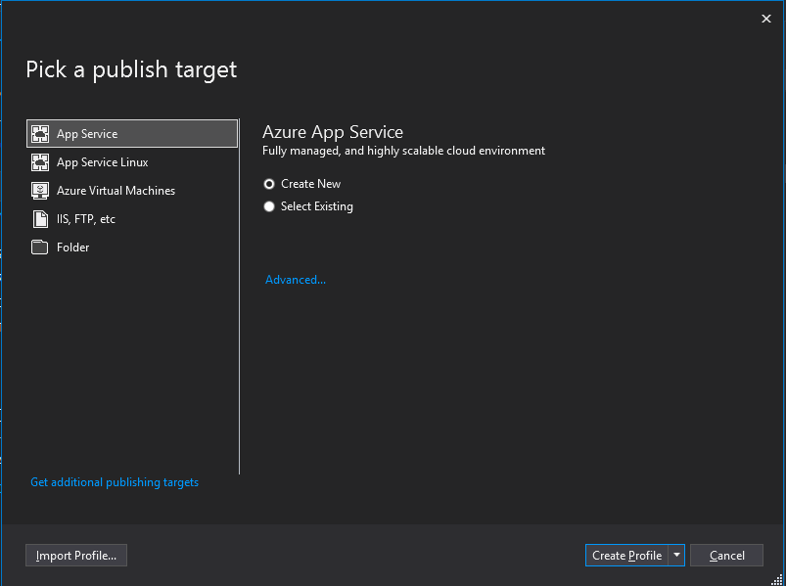

### Create Azure resources

The **Create App Service** dialog appears:

* Enter your subscription.
* The **App Name**, **Resource Group**, and **App Service Plan** entry fields are populated. You can keep these names or change them.

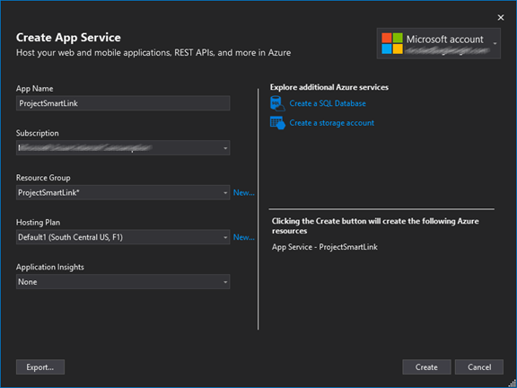

* In the Explore addition Azure services, click on **Create a SQL Database**
* Then the Configure SQL Database window appears.

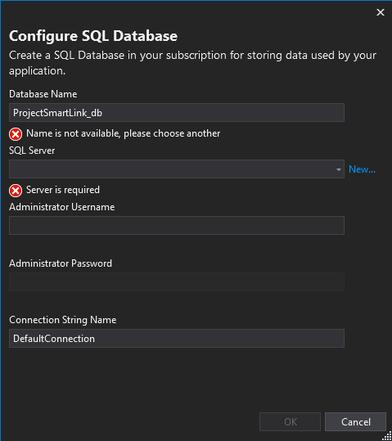

* Select the SQL Server from the dropdown list. If you don’t have a SQL Server configured, then click on the **New…** link

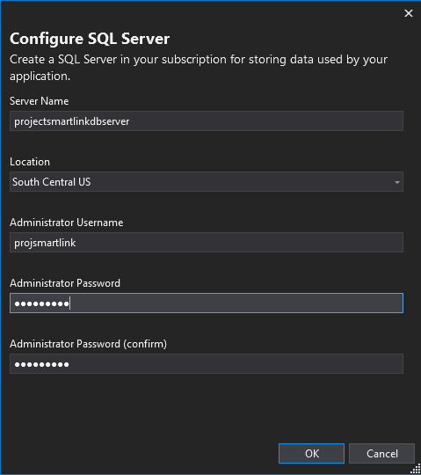

* Enter an administrator user name and password, and then select **OK**. You can keep the default **Server Name**.
* Click on the **OK** button.

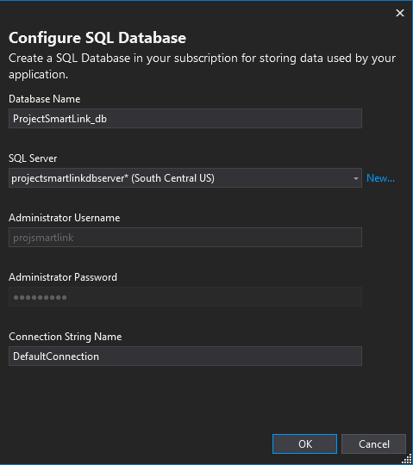

* Leave the **Connection String Name** as is.
* Click on the **OK** button.

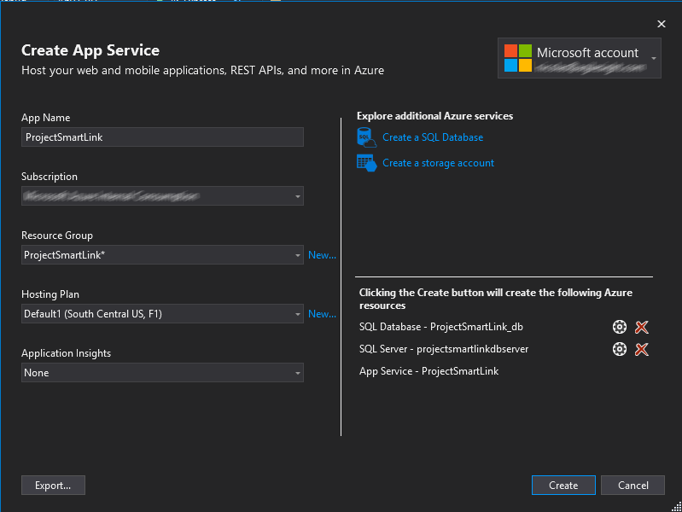

* Click on the **Create** button, to create the profile.

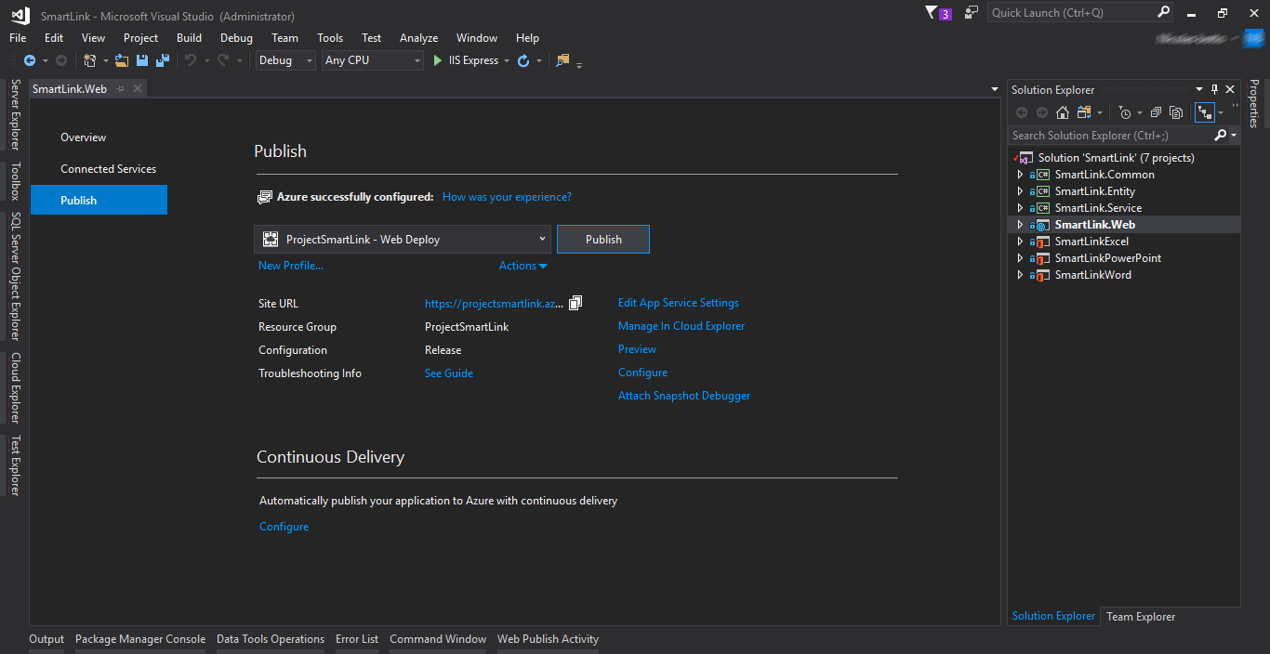

* Click on the **Configure** link.
* Once the window is opened, select the **Settings** tab.
* Expand the **Entity Framework Migrations** and take note of the connection string value as we’ll use it later.
* Click on the **Save** button.

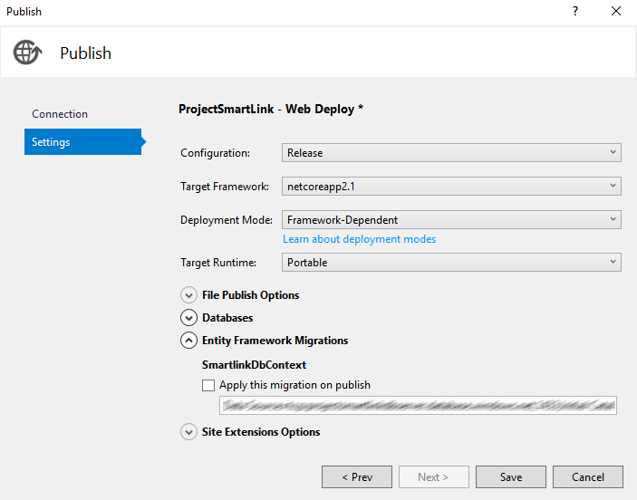

### Configure the application settings:

Open the appsettings.json file under the SmartLink.Web project and fill the required settings:

|  |  |
| --- | --- |
| ClientId | The application id of the registered application in step “Azure App Registration” |
| ClientSecret | The secret of the registered application in step “Azure App Registration” |
| TenantId | The tenant id. |
| SharePointUrl | The url of the sharepoint site |
| AllowedTenants | A list of the tenant ids allowed to invoke the API |
| ConnectionString | The connection string to the SQL Server database you previously copied. |

## 

Finally, right-click on the **ProjectSmartLink.Web** project in Solution Explorer and select **Publish...**. Once the Publish dialog opens, click on the **Publish** button to finish the process.

### Configure SQL Database Firewall settings

1. Sign into [Microsoft Azure portal](https://portal.azure.com) with your Global Administrator account.
2. Choose the SQL databases blade
3. Select the SQL database previously deployed
4. Click on the **Set server firewall** button

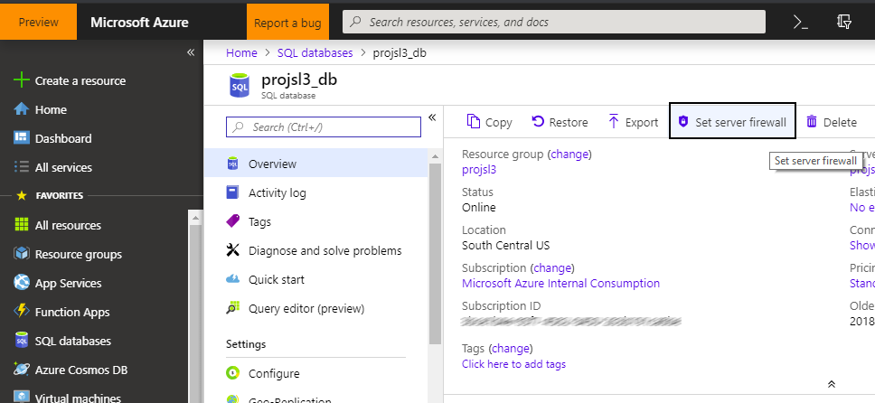

1. Click on **Add client IP** button

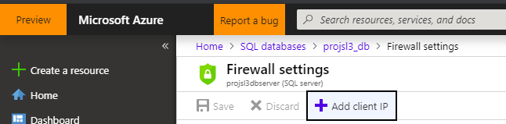

1. Finally click on the **Save** button

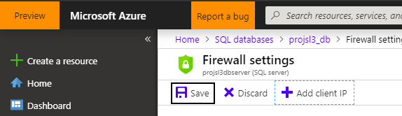

## Configure SharePoint Catalog

1. Open <https://portal.office.com> , sign in with your account.
2. Expand Admin centers on the left navigation.

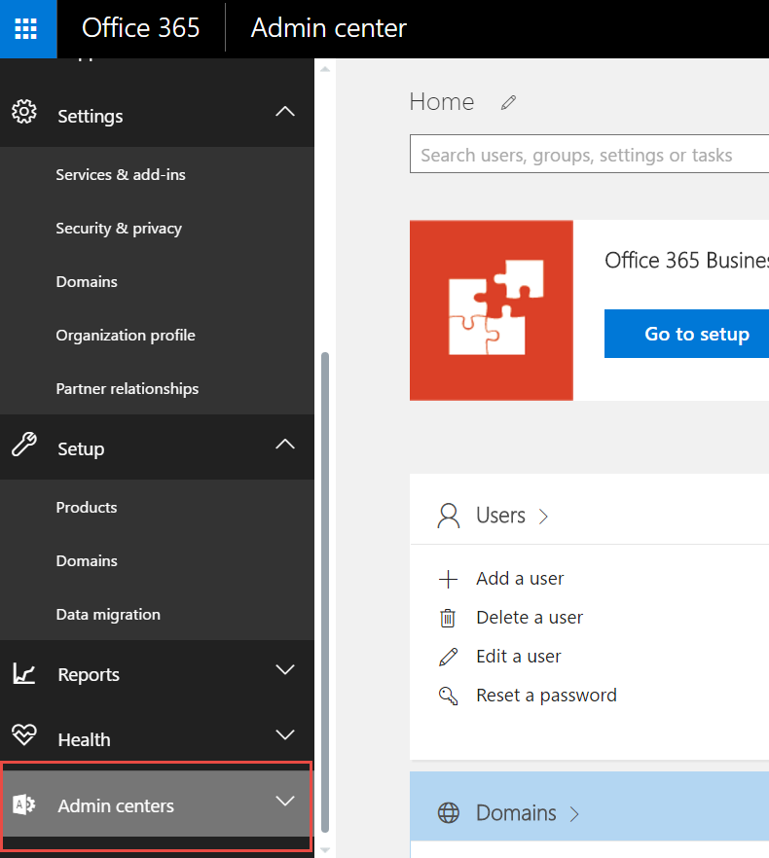

1. Click on SharePoint on the left navigation

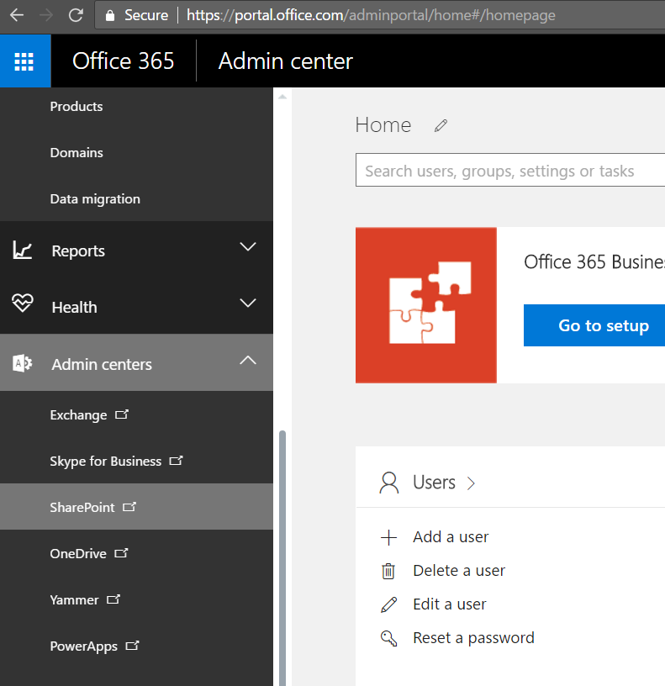

1. A new page will be displayed, find the catalog URL and copy it.

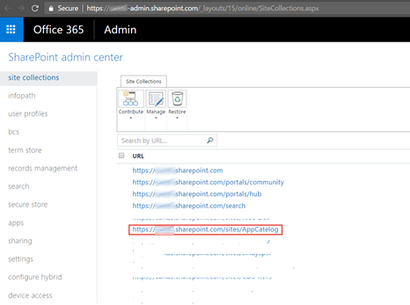

1. Go to the catalog page



1. Click on Apps for Office

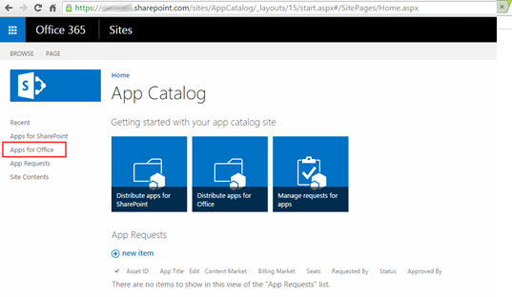

1. Click on Upload

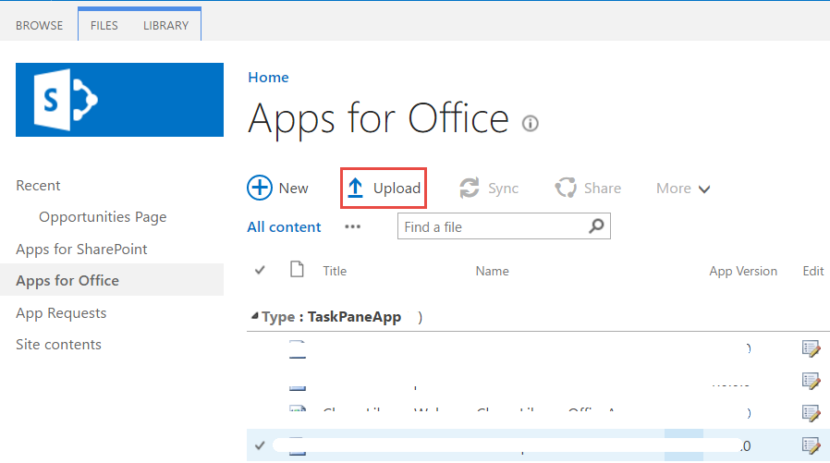

1. Find the app manifest file in:

***$/Addins/ProjectSmartLink/ProjectSmartLinkExcel/ProjectSmartLinkExcelManifest/ProjectSmartLinkExcel.xml***

1. Update the manifest file.
   1. Update the Id with a new generated GUID and you could refer to the link below on how to generate it. <https://guidgenerator.com/online-guid-generator.aspx>
   2. Update the value of display name and description to Project Smart Link.
   3. Update the IconUrl default value to the image path.

**For example:** <https://msfinsmartlinkqa.azurewebsites.net/Images/logo.png>

* 1. Update the hosts to the following elements.

<Host Name="Workbook" />

<Host Name="Document" />

<Host Name="Presentation" />

* 1. Update the source location default value to the one provisioned in Azure.

**For example:** <https://msfinsmartlinkqa.azurewebsites.net/Home/Index>

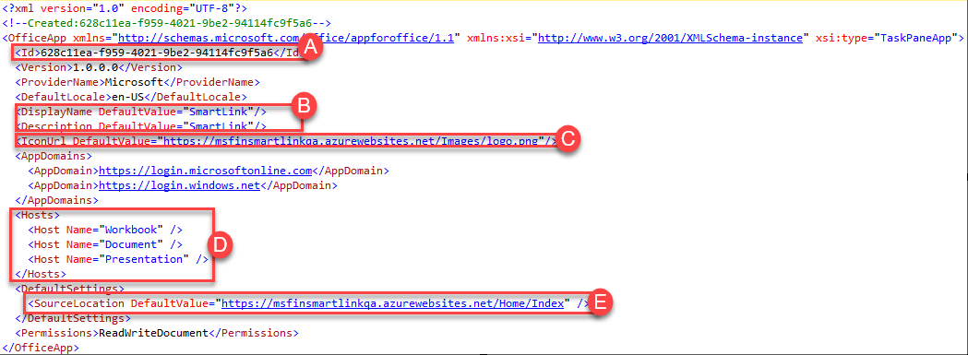

1. Upload word app manifest file to SharePoint catalog.

## Configure SharePoint Document ID Service

**NOTE**:  In order enable the Document ID feature you must be a site collection administrator.

1. Go to the top-level site collection of the O365 site.

**For Example:** <https://golocaldemos.sharepoint.com>

1. Click **Site Actions** and then click **Site Settings**.
2. Under Site Collection Administration, click **Site collection features**.
3. Next to Document ID Service click **Activate**.



1. Go back to site settings page.
2. Under Site Collection Administration, click **Document ID settings**.
3. On the Document ID settings page, check the **Assign Document IDs** check box. Input the begin characters (Such as MSFIN) in **Begin IDs with the following characters** text box, check **Reset all Document IDs in this Site Collection to begin with these characters** check box and select All Sites in **Use this search scope for ID lookup** dropdown.

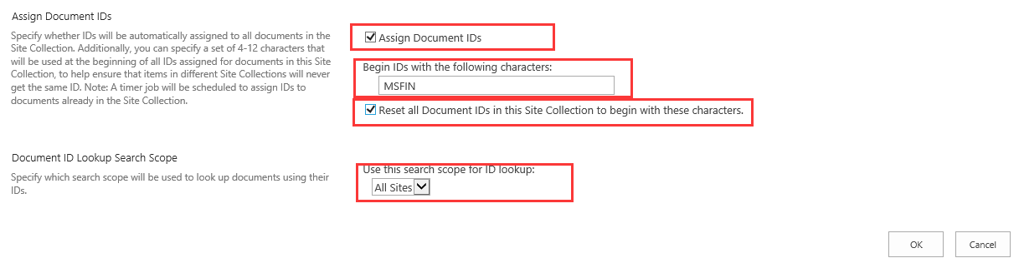

1. Click **OK.**

## Install Excel Add-in

1. Open Excel 2016
2. Sign in with the your O365 account 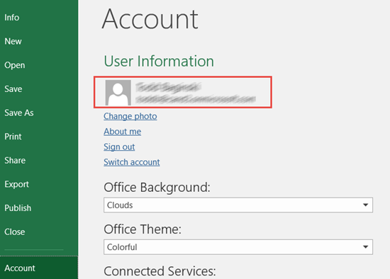
3. Click File | Options

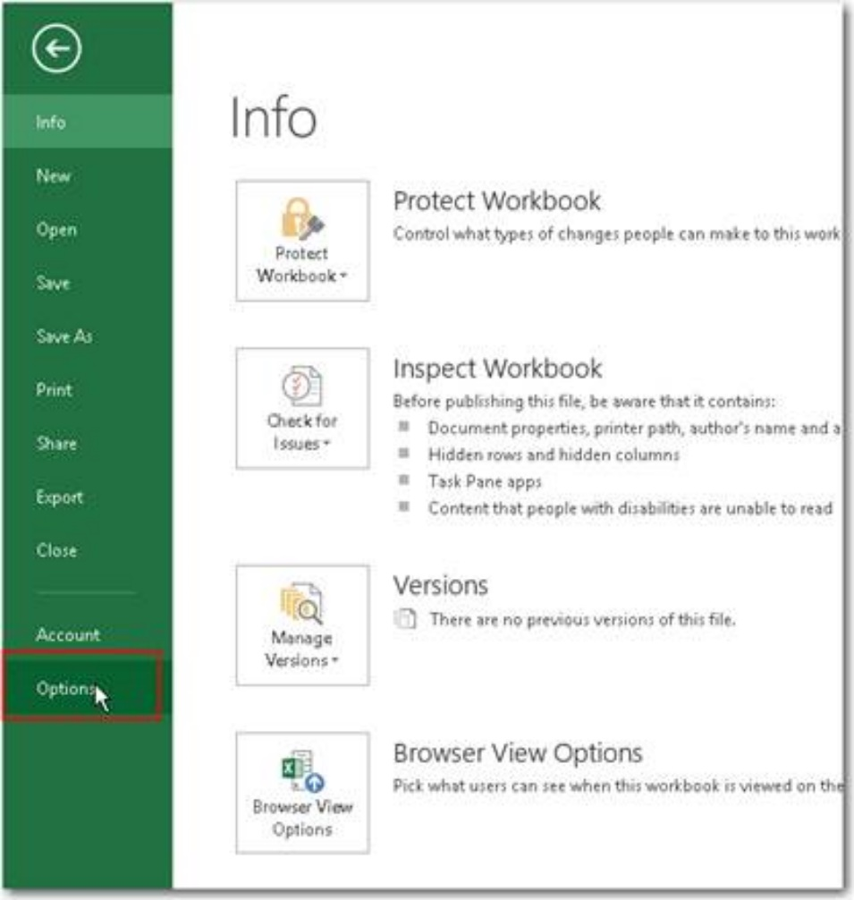

1. Click Trust Center | Trust center settings

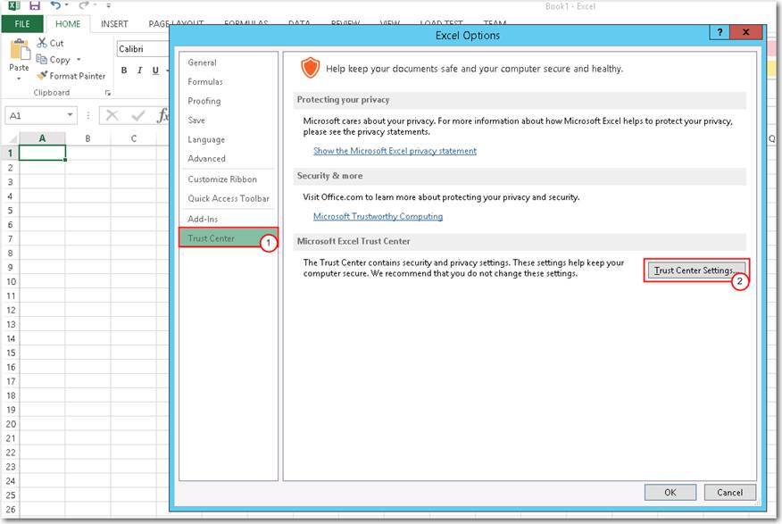

1. Click Trust App Catalogs | Add catalog with the link you found in above

For example: <https://golocaldemos.sharepoint.com/sites/AppCatalog>

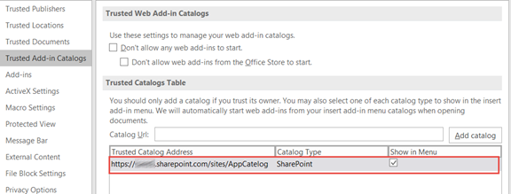

1. Restart the excel.
2. Click Insert and My Add-ins.

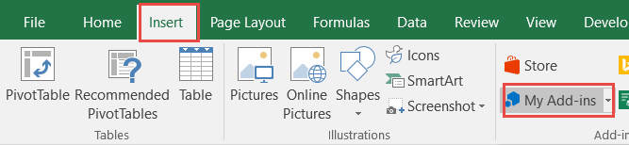

1. Click ‘MY ORGANIZATION’ and insert the SmartLinkExcel.

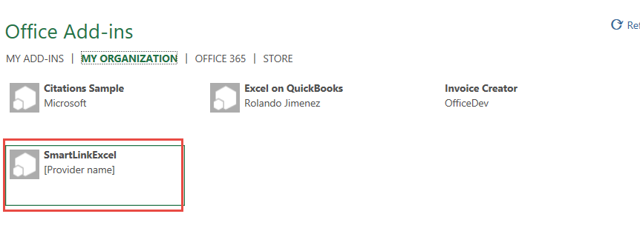

1. Then the Excel Add-in would be shown on the right.

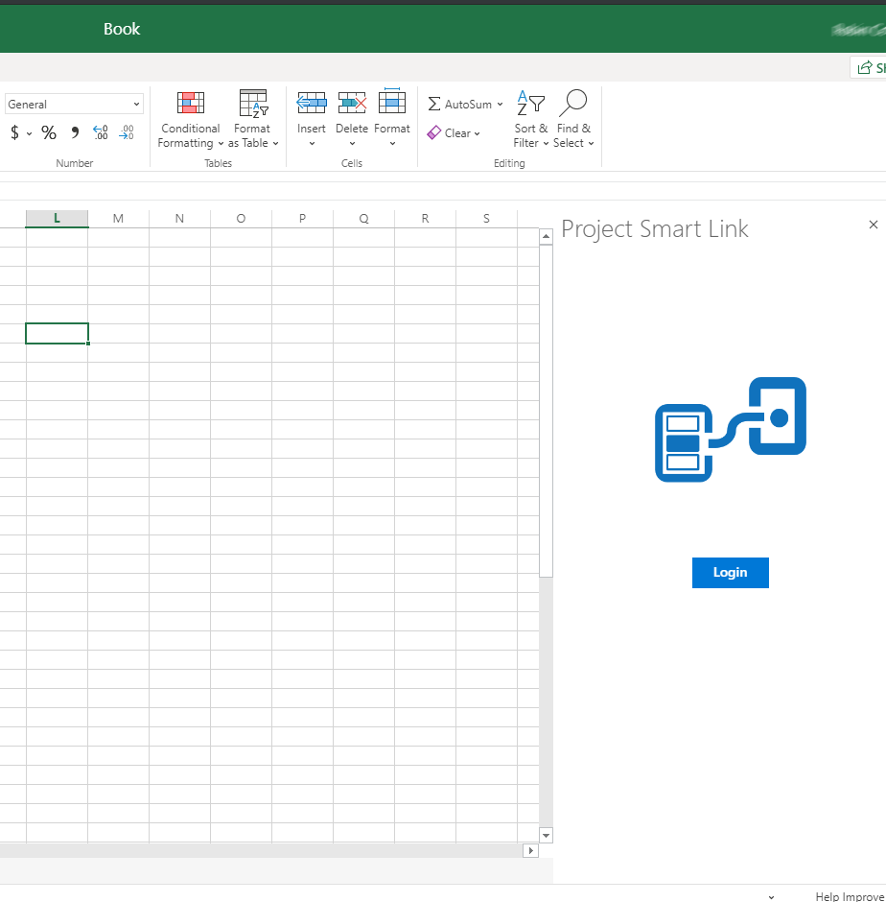

## Install Word Add-in

1. Open Word 2016
2. Sign in with your O365 account

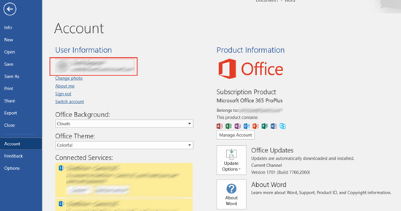

1. Click file | Options.

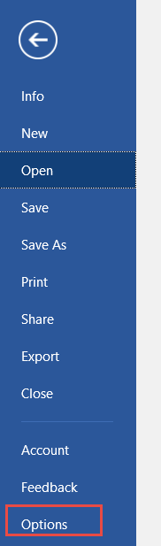

1. Click Trust Center | Trust center settings

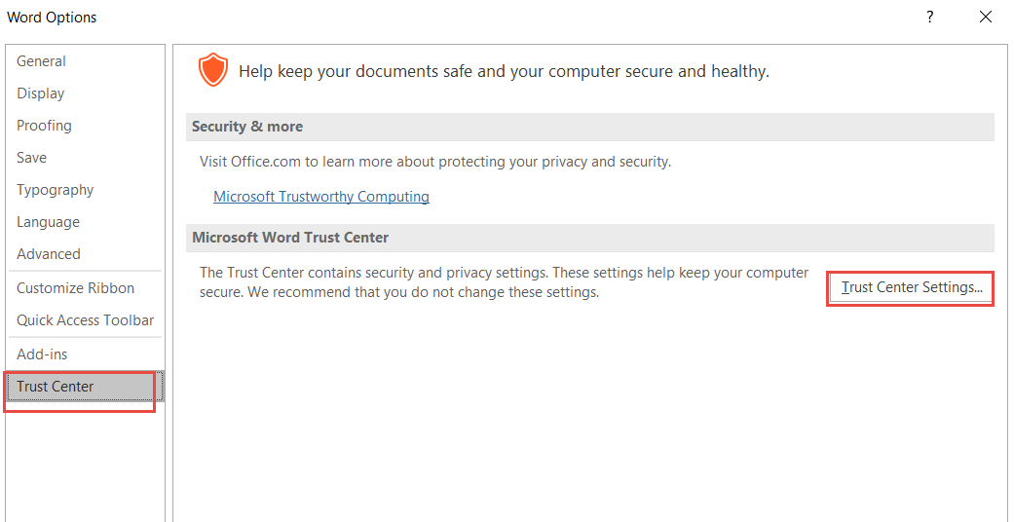

1. Click Trust App Catalogs | Add catalog with the link you found in above

For example: <https://golocaldemos.sharepoint.com/sites/AppCatalog>

1. Restart the Word.
2. Click Insert and My Add-ins.

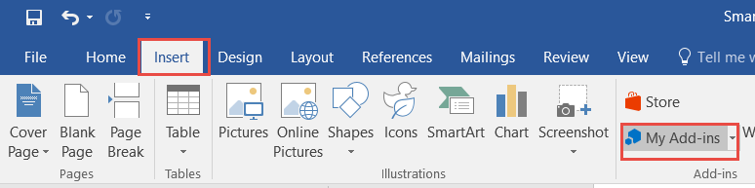

1. Click ‘MY ORGANIZATION’ and insert the ProjectSmartLinkWord.
2. Then the Word Add-in would be shown on the right.